
Faculty of Science

Course: CSCI 2020u – Software System Development & Integration
Component: Assignment
Weight: 10%
Deadline: March 5, 2020 (due by 11:59pm)

Collaboration Policy
You are permitted to work on this assignment in a team, and submit the results as a team. For this sort of assignment, with an open-ended component, the collaboration between multiple team members can be beneficial. Between groups, however, please limit the discussion to the level of general strategy (not code). Groups of size 2 are recommended. Larger groups will be considered with the proviso that the marker will mark your assignment with higher expectations. In any case, be sure that all members of the team fully understand all code, otherwise they will miss intended learning objectives, which may be a considerable disadvantage at exam time.

How to Submit
You will maintain a git repository for this assignment, which is a public repository. To submit the assignment, create a single file ‘README.txt’ that contains instructions on how to download, compile, and run your codes for each question. A .zip, .7z, or .rar file will not be acceptable. Also submit this word file (once you complete) into related drop box on Blackboard before deadline.

Note: Comments are mandatory. Failure to properly document your program will result in a deduction on the marks you receive for this (and any other) assignment.

Remember:
You need to complete this file and submit it in related drop box on Blackboard, in addition to uploading your codes in your git repository, before deadline.

Question 1: Displaying Three Cards

Problem Description:
Display a frame that contains three labels. Each label displays a card, as shown in the figure below. The card image files are named 1.png, 2.png, ..., 54.png and stored in the image/card directory. All three cards are distinct and selected randomly.

The image icons can be found in the attached card folder.

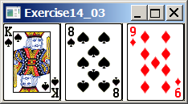

Your Task:
- Create three ImageView and set their icons using the images.
- Display three images from 54 image cards randomly.

Your Code:
Copy-paste your code here:
package sample;
import javafx.application.Application;
import javafx.fxml.FXMLLoader;
import javafx.scene.Parent;
import javafx.scene.Scene;
import javafx.stage.Stage;
import javafx.scene.control.*;
import javafx.scene.layout.*;
import javafx.event.ActionEvent;
import javafx.event.EventHandler;
import javafx.scene.control.Label;
import javafx.geometry.Insets;
import javafx.scene.image.*;
import java.io.*;
public class Main extends Application {
@Override
public void start(Stage s) throws Exception{
// Set stage title
s.setTitle("Cards");
//Generate 3 random numbers (from 1-54)
int random1 = (int )(Math.random() * 54 + 1);
int random2 = (int )(Math.random() * 54 + 1);
int random3 = (int )(Math.random() * 54 + 1);
// Create 3 file input streams (one per card) using random numbers
FileInputStream input1 = new FileInputStream("cards/"+random1+".png");
FileInputStream input2 = new FileInputStream("cards/"+random2+".png");
FileInputStream input3 = new FileInputStream("cards/"+random3+".png");
// Create the images for each card
Image card1 = new Image(input1);
Image card2 = new Image(input2);
Image card3 = new Image(input3);
// Create the ImageViews for each card
ImageView c1 = new ImageView(card1);
ImageView c2 = new ImageView(card2);
ImageView c3 = new ImageView(card3);
// Create a label for each card
Label card1L = new Label("", c1);
Label card2L = new Label("", c2);
Label card3L = new Label("", c3);
// Create a horizontal box for cards
HBox hBox = new HBox(10);
hBox.setPadding(new Insets(1,1,1,1));
hBox.getChildren().add(card1L);
hBox.getChildren().add(card2L);
hBox.getChildren().add(card3L);
// Create the scene
Scene sc = new Scene(hBox);
// Set the scene
s.setScene(sc);
// Show the scene
s.show();
}
public static void main(String[] args) {
launch(args);
}
}

Screen shots:
Include two screen shots here:

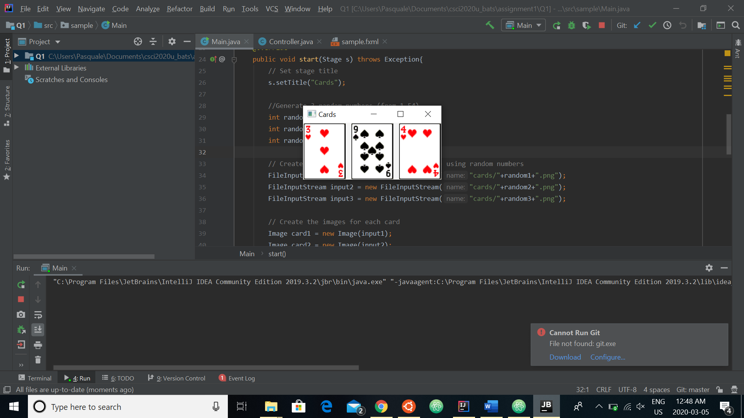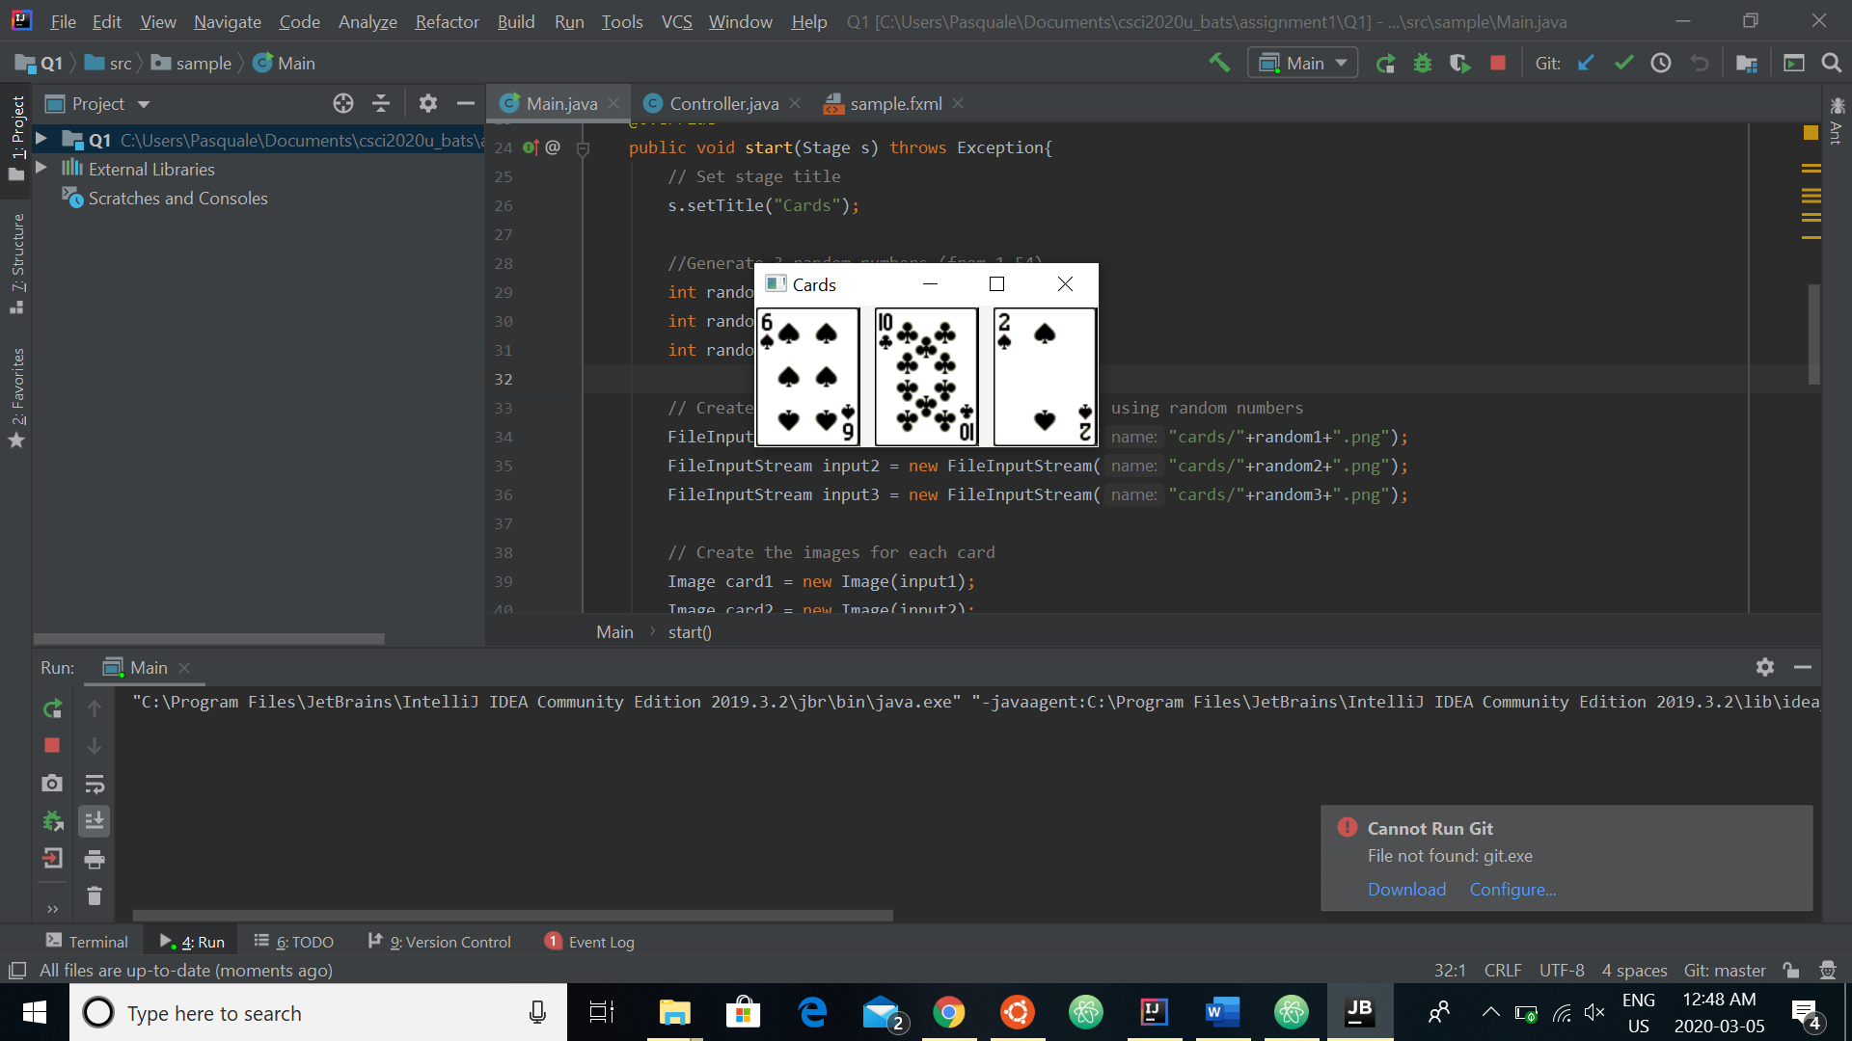

Question 2: Investment-Value calculator

Problem Description:
Write a program that calculates the future value of an investment at a given interest rate for a specified number of years. The formula for the calculation is as follows:

futureValue = investmentAmount * (1 + monthlyInterestRate)years*12

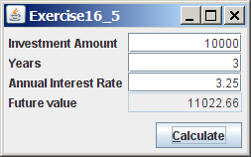

Your Task:
Use text fields for interest rate, investment amount, and years. Display the future amount in a text field when the user clicks the Calculate button, as shown in the figure.

Your Code:
Copy-paste your code here.
package sample;
import javafx.application.Application;
import javafx.fxml.FXMLLoader;
import javafx.scene.Parent;
import javafx.scene.Scene;
import javafx.scene.control.*;
import javafx.stage.Stage;
import javafx.scene.layout.HBox;
import javafx.scene.layout.GridPane;
import javafx.event.ActionEvent;
import javafx.event.EventHandler;
import javafx.scene.text.Text;
import javafx.scene.paint.Color;
import javafx.geometry.Pos;
import javafx.geometry.Insets;
import java.math.RoundingMode;
import java.text.DecimalFormat;
public class Main extends Application {
@Override
public void start(Stage primaryStage) {
// Set stage title
primaryStage.setTitle("Future Value Calculation");
// Create grid
GridPane grid = new GridPane();
grid.setAlignment(Pos.TOP_LEFT);
grid.setHgap(10);
grid.setVgap(10);
grid.setPadding(new Insets(5, 10, 10, 10));
// Create each appropriate label and text field for the 4 parameters
// Investment amount label and text field
Label invAmount = new Label("Investment Amount:");
grid.add(invAmount, 0, 1);
TextField invTextField = new TextField();
invTextField.setPromptText("Investment Amount");
grid.add(invTextField, 1, 1);
// Number of years label and text field
Label years = new Label("Years:");
grid.add(years, 0, 2);
TextField yearsTextField = new TextField();
yearsTextField.setPromptText("Years");
grid.add(yearsTextField, 1, 2);
// Annual rate label and text field
Label annualRate = new Label("Annual Interest Rate:");
grid.add(annualRate, 0, 3);
TextField rateTextField = new TextField();
rateTextField.setPromptText("Annual Interest Rate");
grid.add(rateTextField, 1, 3);
// Future value label and text field
Label futureValue = new Label("Future Value:");
grid.add(futureValue, 0, 4);
TextField fvTextField = new TextField();
// Ensure user cannot edit this text field
fvTextField.setEditable(false);
fvTextField.setPromptText("Press the button");
grid.add(fvTextField, 1, 4);
// Create button to execute calculation
Button btn = new Button("Calculate");
HBox hbBtn = new HBox(10);
hbBtn.setAlignment(Pos.BOTTOM_RIGHT);
hbBtn.getChildren().add(btn);
grid.add(hbBtn, 1, 7);
// Set button action to do calculation
btn.setOnAction(e -> {
Double invA = Double.valueOf(invTextField.getText());
Double y = Double.valueOf(yearsTextField.getText());
Double rate = Double.valueOf(rateTextField.getText());
// Set decimal format to round the future value
DecimalFormat df = new DecimalFormat("0.00");
// Calculate future value
Double finalFV = (invA * Math.pow((1+rate/100),y));
// Display future value to the appropriate text field
fvTextField.setText(df.format(finalFV));
});
// Create, set and display scene
Scene scene = new Scene(grid);
primaryStage.setScene(scene);
primaryStage.show();
}
public static void main(String[] args) {
launch(args);
}
}

Screen shots:
Include two screen shots here:

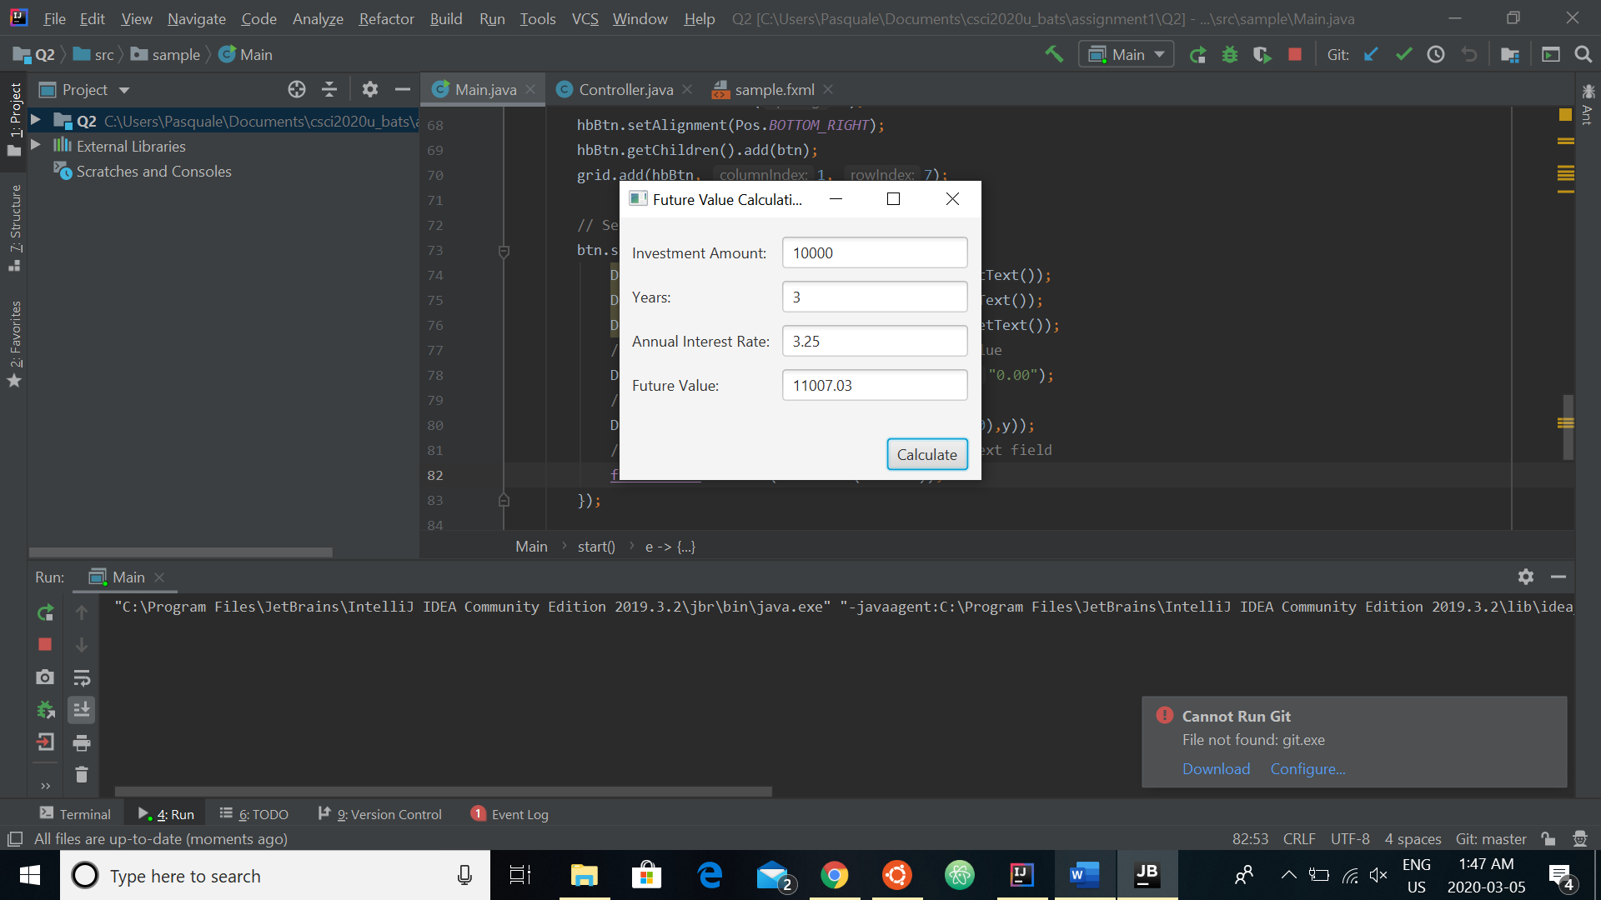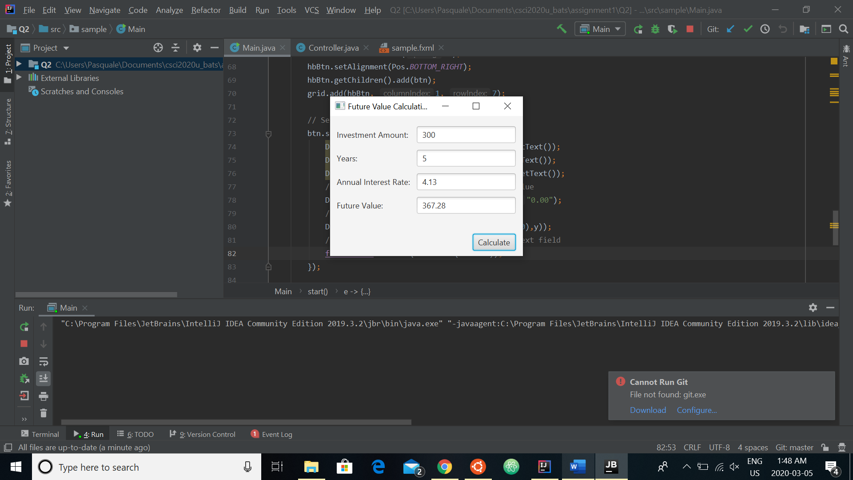
Question 3: Dragging Points on a Circle

Problem Description:
Draw a circle with three random points on the circle. Connect the points to form a triangle. Display the angles in the triangle. Use the mouse to drag a point along the perimeter of the circle. As you drag it, the triangle and angles are redisplayed dynamically.

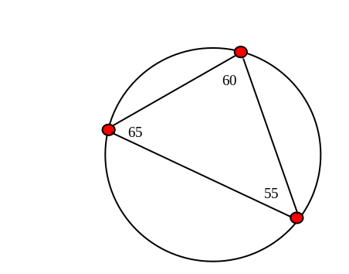

Here is the formula to compute angles:

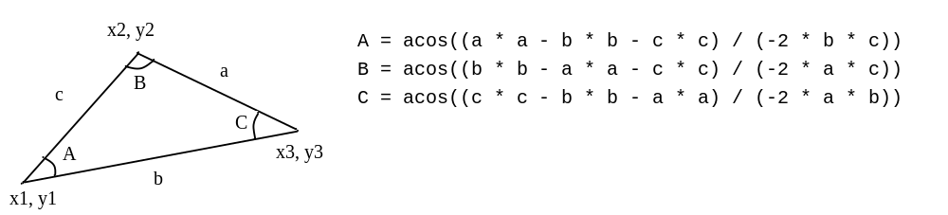

Your Code:
Copy-paste your code here:
package sample;
import javafx.application.Application;
import javafx.geometry.Point2D;
import javafx.scene.Scene;
import javafx.scene.layout.Pane;
import javafx.scene.shape.Circle;
import javafx.scene.shape.Line;
import javafx.scene.text.Text;
import javafx.stage.Stage;
import java.awt.*;
// To note: I built this off of in-class example code, hence some similarities
public class Main extends Application {
private double radius = 10;
Circle[] circle = {new Circle(40, 40, 10),
new Circle(140, 40, 10), new Circle(60, 140, 10)};
private Line line1 = new Line();
private Line line2 = new Line();
private Line line3 = new Line();
private Text[] text = {new Text(), new Text(), new Text()};
Circle big = new Circle(100,100,50);
@Override // Override the start method in the Application class
public void start(Stage primaryStage) {
Pane pane = new Pane();
// Set colours for the circles
big.setStroke(javafx.scene.paint.Color.BLACK);
big.setFill (null);
for (int i = 0; i < 3; i++) {
circle[i].setFill(javafx.scene.paint.Color.RED);
circle[i].setStroke(javafx.scene.paint.Color.BLACK);
}
// Set random locations for points along big circle
for (int i=0; i<3; i++) {
// Set random X and Y for point
double randomX = (Math.random() * 200+1);
double randomY = (Math.random() * 200+1);
Point2D bigCenter = new Point2D(big.getCenterX(), big.getCenterY());
// Use random X and Y for calculation of location along circle
Point2D oldPoint = new Point2D(randomX, randomY);
Point2D bigCenterToPoint = oldPoint.subtract(bigCenter);
Point2D bigCenterToNewPoint = bigCenterToPoint.normalize().multiply(big.getRadius());
Point2D newPoint = bigCenterToNewPoint.add(bigCenter);
// Set new random location
circle[i].setCenterX(newPoint.getX());
circle[i].setCenterY(newPoint.getY());
}
// Set lines
setLines();
// Add all objects to the pane
pane.getChildren().addAll(circle[0], circle[1], circle[2],
line1, line2, line3, text[0], text[1], text[2], big);
// Create a scene and place it in the stage
Scene scene = new Scene(pane, 400, 250);
primaryStage.setTitle("Drag Points"); // Set the stage title
primaryStage.setScene(scene); // Place the scene in the stage
primaryStage.show(); // Display the stage
// Set dragging of points along big circle
circle[0].setOnMouseDragged(e -> {
// Get big circle center and mouse location
Point2D bigCenter = new Point2D(big.getCenterX(), big.getCenterY());
Point2D mouse = new Point2D(e.getX(), e.getY());
// Find current vector from center to mouse location
Point2D bigCenterToPoint = mouse.subtract(bigCenter);
// Normalize vector with radius to ensure point stays on circle
Point2D bigCenterToNewPoint = bigCenterToPoint.normalize().multiply(big.getRadius());
Point2D newPoint = bigCenterToNewPoint.add(bigCenter);
// Set the new coordinates and redraw lines
circle[0].setCenterX(newPoint.getX());
circle[0].setCenterY(newPoint.getY());
setLines();
});
circle[1].setOnMouseDragged(e -> {
// Get big circle center and mouse location
Point2D bigCenter = new Point2D(big.getCenterX(), big.getCenterY());
Point2D mouse = new Point2D(e.getX(), e.getY());
// Find current vector from center to mouse location
Point2D bigCenterToPoint = mouse.subtract(bigCenter);
// Normalize vector with radius to ensure point stays on circle
Point2D bigCenterToNewPoint = bigCenterToPoint.normalize().multiply(big.getRadius());
Point2D newPoint = bigCenterToNewPoint.add(bigCenter);
// Set the new coordinates and redraw lines
circle[1].setCenterX(newPoint.getX());
circle[1].setCenterY(newPoint.getY());
setLines();
});
circle[2].setOnMouseDragged(e -> {
// Get big circle center and mouse location
Point2D bigCenter = new Point2D(big.getCenterX(), big.getCenterY());
Point2D mouse = new Point2D(e.getX(), e.getY());
// Find current vector from center to mouse location
Point2D bigCenterToPoint = mouse.subtract(bigCenter);
// Normalize vector with radius to ensure point stays on circle
Point2D bigCenterToNewPoint = bigCenterToPoint.normalize().multiply(big.getRadius());
Point2D newPoint = bigCenterToNewPoint.add(bigCenter);
// Set the new coordinates and redraw lines
circle[2].setCenterX(newPoint.getX());
circle[2].setCenterY(newPoint.getY());
setLines();
});
}
private void setLines() {
// Set all lines to draw between the points
line1.setStartX(circle[0].getCenterX());
line1.setStartY(circle[0].getCenterY());
line1.setEndX(circle[1].getCenterX());
line1.setEndY(circle[1].getCenterY());
line2.setStartX(circle[0].getCenterX());
line2.setStartY(circle[0].getCenterY());
line2.setEndX(circle[2].getCenterX());
line2.setEndY(circle[2].getCenterY());
line3.setStartX(circle[1].getCenterX());
line3.setStartY(circle[1].getCenterY());
line3.setEndX(circle[2].getCenterX());
line3.setEndY(circle[2].getCenterY());
// Compute angles
double a = new Point2D(circle[2].getCenterX(), circle[2].getCenterY()).
distance(circle[1].getCenterX(), circle[1].getCenterY());
double b = new Point2D(circle[2].getCenterX(), circle[2].getCenterY()).
distance(circle[0].getCenterX(), circle[0].getCenterY());
double c = new Point2D(circle[1].getCenterX(), circle[1].getCenterY()).
distance(circle[0].getCenterX(), circle[0].getCenterY());
double[] angle = new double[3];
angle[0] = Math.acos((a * a - b * b - c * c) / (-2 * b * c));
angle[1] = Math.acos((b * b - a * a - c * c) / (-2 * a * c));
angle[2] = Math.acos((c * c - b * b - a * a) / (-2 * a * b));
for (int i = 0; i < 3; i++) {
text[i].setX(circle[i].getCenterX());
text[i].setY(circle[i].getCenterY() - radius);
text[i].setText(String.format("%.2f", Math.toDegrees(angle[i])));
}
}
public static void main(String[] args) {
launch(args);
}
}

Screen shots:
Include two screen shots here:
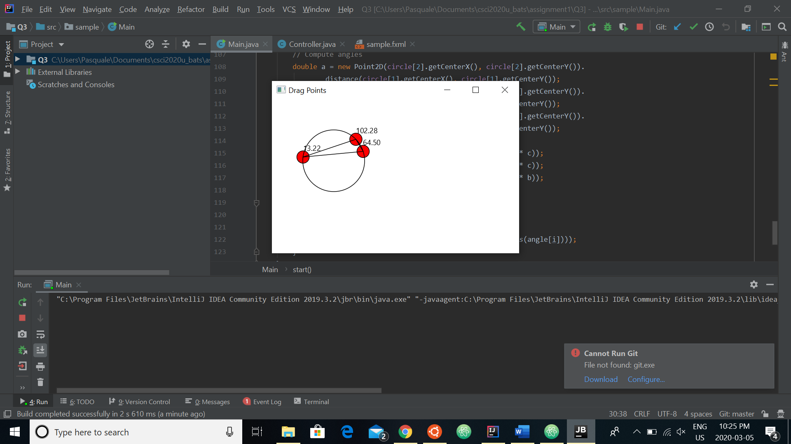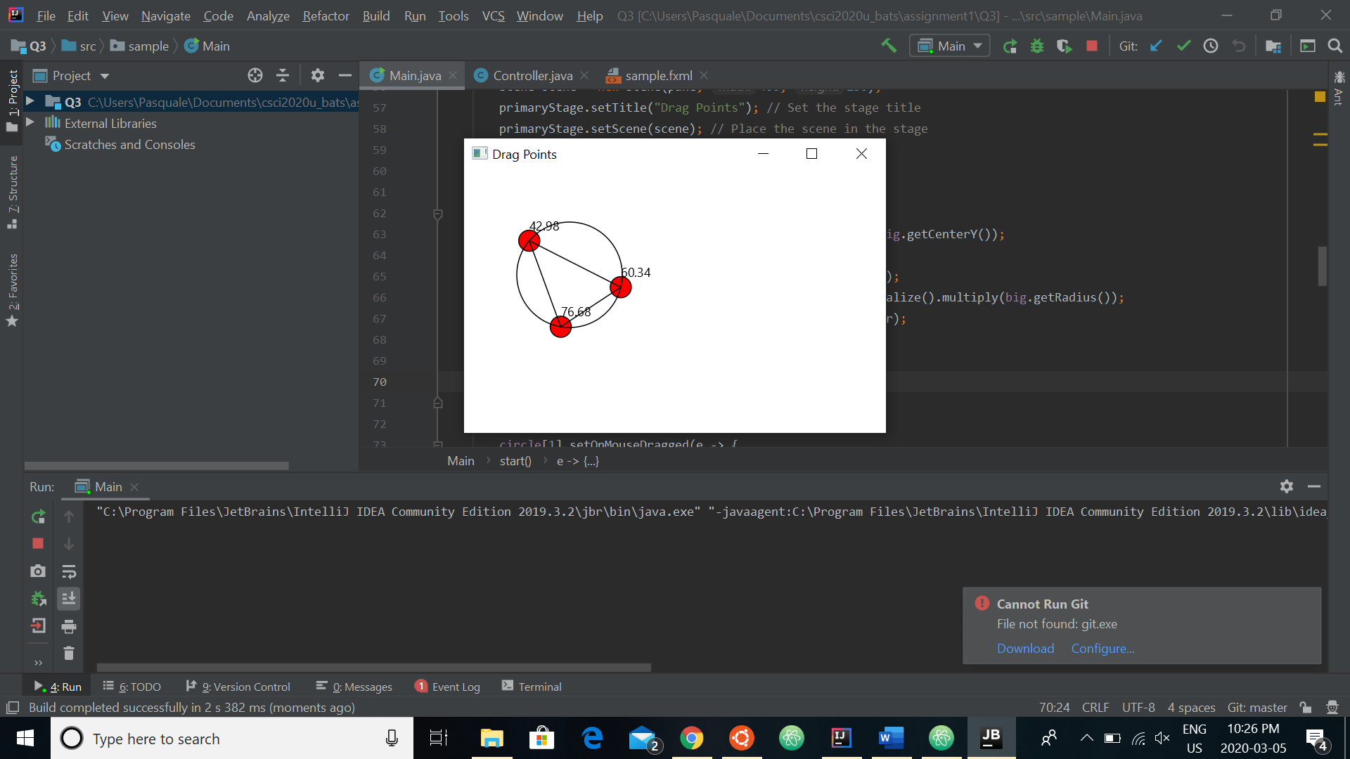
Question 4: Histogram

Problem Description:
Develop a program that displays a histogram to show the occurrences of each letter in a text area. The histogram should show the occurrences of each letter in a text file, as shown in the following figure. Assume that the letters are not case sensitive.

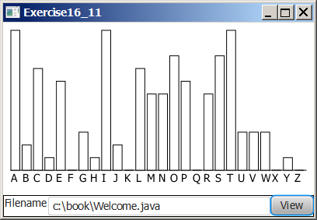

Your Task:
- Place a pane that will display the histogram in the center of the frame.
- Place a label and a text field in a panel, and put the panel in the south side of the frame. The text file will be entered from this text field.
- Pressing the Enter key on the text field causes the program to count the occurrences of each letter and display the count in a histogram.

Your Code:
Copy-paste your code here:
package sample;
import javafx.application.Application;
import javafx.event.EventHandler;
import javafx.fxml.FXMLLoader;
import javafx.scene.Parent;
import javafx.scene.Scene;
import javafx.scene.control.Button;
import javafx.scene.control.Label;
import javafx.scene.control.TextField;
import javafx.scene.layout.Pane;
import javafx.stage.Stage;
import java.awt.event.ActionEvent;
import java.io.BufferedReader;
import java.io.FileReader;
import java.io.IOException;
import java.util.HashMap;
import javafx.scene.*;
import javafx.scene.shape.*;
import javafx.scene.paint.*;
import javafx.scene.canvas.*;
import javafx.scene.text.Font;
import javafx.geometry.Pos;
import javafx.geometry.Insets;
public class Main extends Application {
String file = "test.txt";
@Override
public void start(Stage primaryStage) throws IOException{
// Create filename variable
// Create array to count each letter in file and max count variable
double[] numberOfLetters = new double [26];
double maxCount = 0;
// Initialize array
for (int i=0;i<26;i++){
numberOfLetters[i] = 0;
}
// Create alphabet array (for comparison)
char[] alphabet = "abcdefghijklmnopqrstuvwxyz".toCharArray();
// Load the text file
BufferedReader reader = new BufferedReader(new FileReader(file));
// Read line by line
while (true) {
String line = reader.readLine();
// End loop at null line
if (line == null) {
break;
}
// Check each line for number of each letter, letter by letter
for (int i = 0; i < line.length(); i++) {
char c = line.charAt(i);
if (c != ' ') {
// Check which letter and increment count
for (int j=0; j<26; j++){
if(c == alphabet[j]){
numberOfLetters[j]++;
// Update maxCount if needed
if(numberOfLetters[j]>maxCount){
maxCount = numberOfLetters[j];
}
}
}
}
}
}
// Close the reader
reader.close();
// Set the scene and canvas for histogram
Pane root = new Pane();
Scene s = new Scene(root, 300, 300, Color.WHITE);
final Canvas canvas = new Canvas(1000,500);
GraphicsContext gc = canvas.getGraphicsContext2D();
// Draw a rectangle for each letter with relative height
gc.setFill(Color.BLACK);
gc.setStroke(Color.BLACK);
for (int i = 0; i<26;i++) {
gc.fillRect(20+(i*10), 50+(100-((numberOfLetters[i])/maxCount)*100), 8, ((numberOfLetters[i])/maxCount)*100);
}
// Add bottom axis and axis label (letters)
gc.fillRect(20,150,258,1);
gc.setFont(new Font("Times New Roman", 11));
gc.strokeText("A B C D E F G H I J K L M N O P Q R S T U V W X Y Z",20,160);
// Add canvas to pane
root.getChildren().add(canvas);
// Add label and text to pane
Label fileName = new Label("Filename:");
fileName.setLayoutX(20);
fileName.setLayoutY(190);
TextField fileTextField = new TextField();
fileTextField.setPromptText("Type a filename");
fileTextField.setLayoutX(80);
fileTextField.setLayoutY(190);
root.getChildren().add(fileName);
root.getChildren().add(fileTextField);
// Add button
Button btn = new Button();
btn.setText("View");
btn.setOnAction(e -> {
String fs = String.valueOf(fileTextField.getText());
// Display future value to the appropriate text field
file = fs;
});
btn.setLayoutX(230);
btn.setLayoutY(190);
root.getChildren().add(btn);
// Set scene and display
primaryStage.setTitle("Number of Letters");
primaryStage.setScene(s);
primaryStage.show();
}
public static void main(String[] args) {
launch(args);
}
}

Screen shots:
Include two screen shots here:
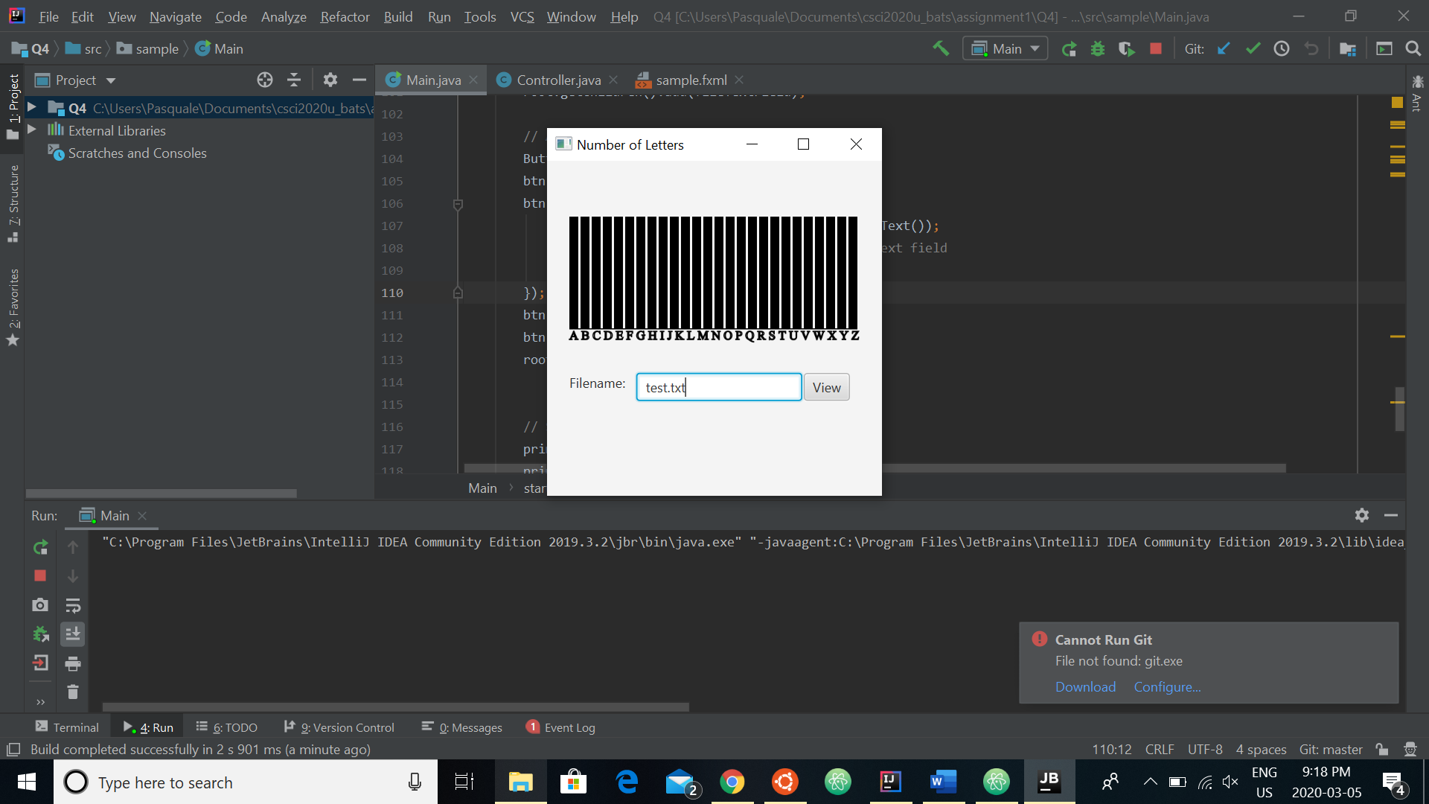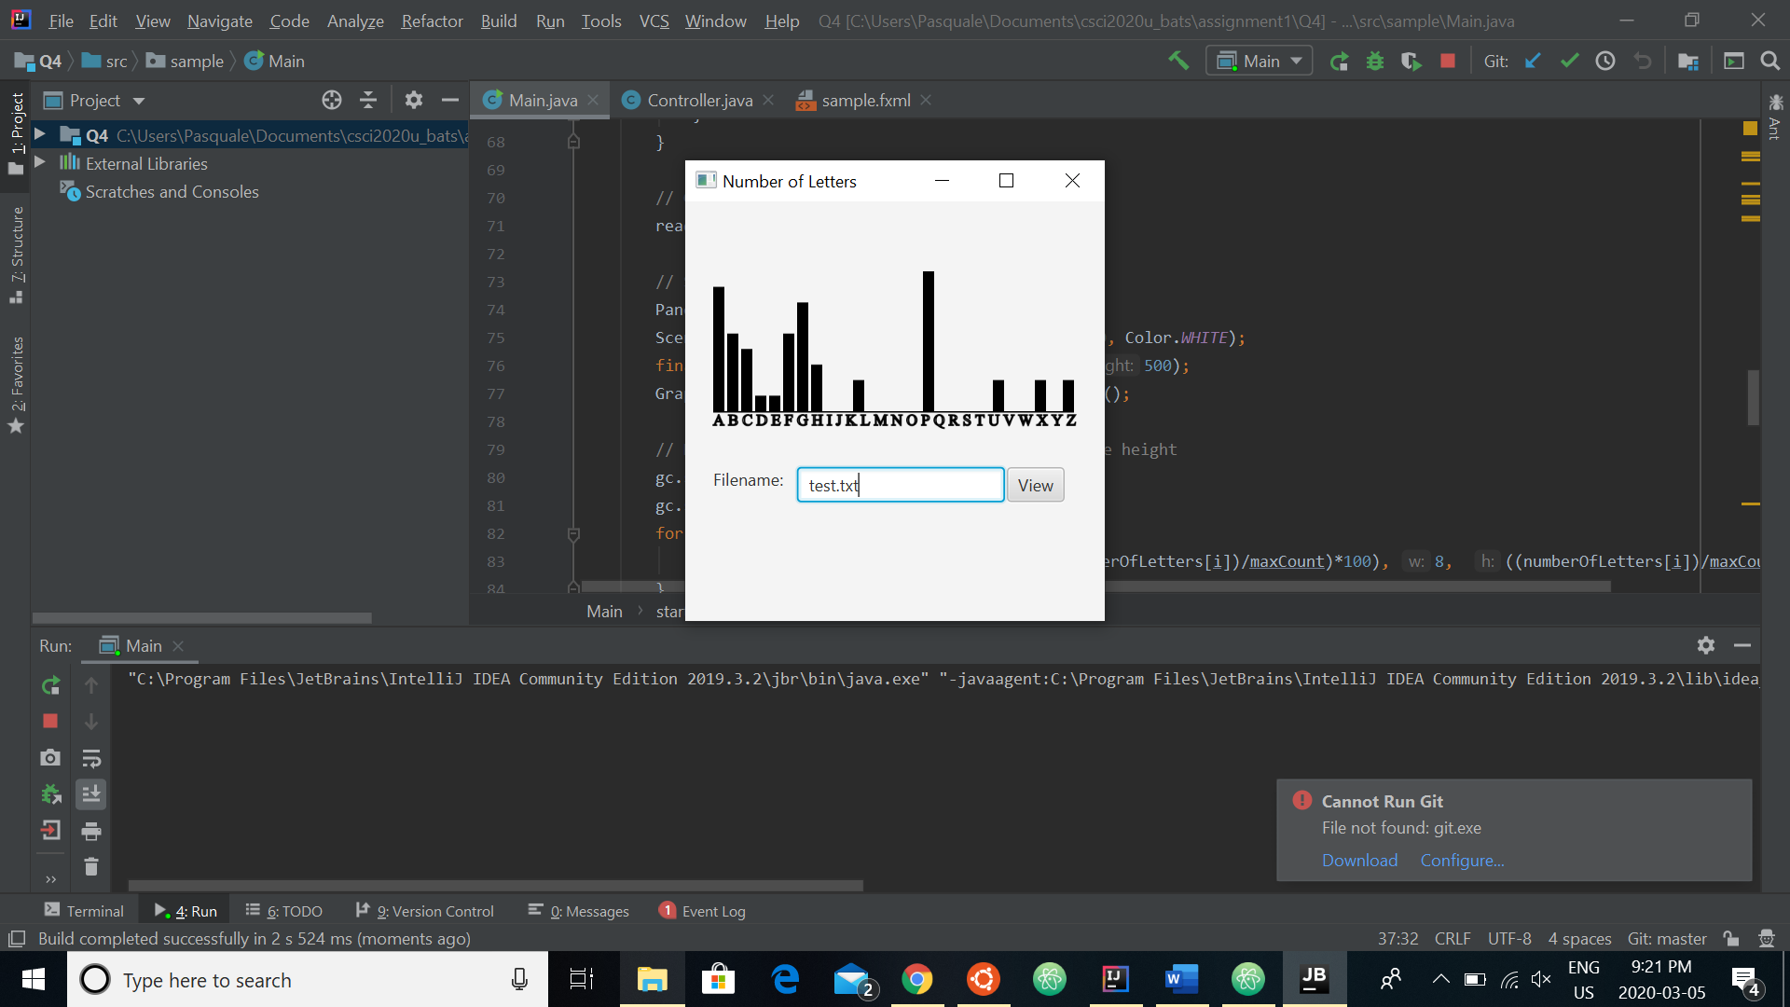

Remember:

You need to complete this file and submit it in related drop box on Blackboard, in addition to uploading your codes in your git repository, before deadline.

